**3D puppet supplies**

* Cotton balls for stuffing (Rachel)
* Body
  + Paper towel tube
  + Arms - cloth plus straw or cotton or wire
  + Head - styrofoam ball or newspaper plus tape (has to be proportional to body)
  + Hair - yarn
* Clothes (fabric)
  + Servant
    - Felt apron (add a dimension)
  + Ballgown
    - Tulle (add a dimension)
* Newspaper for head
* Tape
* Hot glue gun
* Dowels
* Other props: cutouts for birds or mice

**Supplies as a List**

* Cotton balls (Rachel)
* Yarn for hair (Rachel)
* Ballgown cloth
  + Tulle (Rachel)
  + Blue cloth (Rachel)
* Servant dress cloth
  + Felt for apron (Rachel)
  + Other dress cloth
* Cloth for arms
* Wire for arms (Aiza)
* Dowels
* Styrofoam for head
* Tape (Rachel)
* Paper towel tube (Rachel)
* **Cardstock for 2D puppets/animal cutouts (we don’t know what we need yet)**
* **Thick yarn for hair**
* Hot glue gun (Aiza)

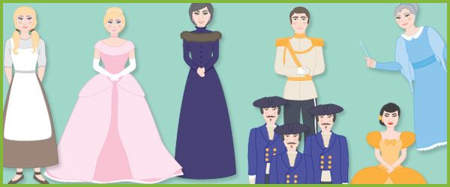

**Scenes**: 4-5 big ones with choices

1. Cleaning: kitchen or fireplace?
   1. If kitchen - Help from the birds (Disney)
   2. If fireplace - the Grimms (lentils)
2. Step-mom yelling: do I suck it up or say something back?
   1. Sucks it up: gets done with work faster and has time to work on her dress
   2. Yells back: Phone gets taken away and she has to get it back with the help of her mice or something
3. Fairy godmother sponsorship: do I go to the ball or not
   1. If yes: original story (go to the ball three times)?
   2. If no: get jealous of stepsisters and either go the last time or scheme to get the prince to come over through insta posts
      1. Someone else could marry the prince
      2. Cinderella or the prince could end up sad
4. Prince comes over and falls in love: do I invite my step-mom and sisters to my wedding?
   1. If yes: they get their eyes plucked out
   2. If no: they stay at home → what’s the ‘fun’ in this? Maybe a sassy insta post about how she upgraded from a house to a castle

Up the stakes

* Get just a beginning and an end, and more improv the inbetween
* Focusing on products
* Develop props from this

**Scenes:**

1. 1. **Kitchen**
      1. <https://youtu.be/-F5qgEBHAVM?t=48>
   2. **Fireplace** 
      1. <https://youtu.be/1i8XVQ2pswg?t=15>
2. 1. **Suck it up**
      1. <https://youtu.be/1i8XVQ2pswg?t=14>
   2. **Yell Back**
3. 1. **Go to the Ball**
      1. <https://www.youtube.com/watch?v=iXJvxEHSv5E>

**Posts**:

* PR package from Fairy Godmother, LLC. - check out tailoring services
* New Video coming
* Animal advocacy
* Fairytale friday
* ootd
* Tbt’s
* Life’s a balance of work and magic
* Shoe half off

**Stories**:

* Any guesses for my next video?
* Filming an Insta controls my life tomorrow
* Clean the Kitchen or fireplace
  + 
* Step-mom yelling: suck it up or say something back
  + 
* Do I go to ball or not (with sponsored post)
  + 
* Invite step-mom and sister to wedding: yes or no
  + 

Things to do:

* Premake stories to post irl with polls
* Posts
* Figure out puppets for each scene
* Background tracks - disney and sad

Cinderella Soundtrack: <https://www.youtube.com/watch?v=JPcXWyNLP54&list=PLkLimRXN6NKy2TonHW_Q9Irjq_Gv01K4a>

Full Movie: <https://www.youtube.com/watch?v=rul4vBmVUmM>